K8s lab part 3– YAMLling your first storage

1. Now to test with some examples. Create a folder in the VM and copy the contents from the “yaml examples” folder in there:

mkdir ~/yaml

Now copy the files in there so you get yaml/iSCSI and yaml/nfs folders. Using MobaXterm you should be able to just drag and drop the files. After folder creation, first click the green “refresh” button then drag-and-drop the files into the yaml folder:

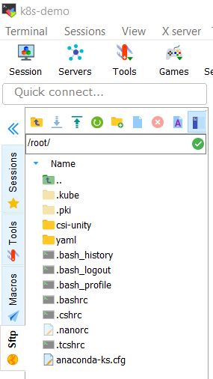

1. Provision storage and connect it up to a pod:

cd ~/yaml/iscsi

kubectl apply -f pvc.yml

kubectl apply -f nginx-pvc.yml

kubectl get pvc

kubectl get pod nginx-pvc

* Verify that the pvc was created and that the pod is running. If something is “pending” just wait; the PVC has to be created on the Unity which takes some time, and only then the pod gets created.
* When you login to Unisphere of the UnityVSA you should be able to see a new 5Gb block volume named csivol-xxxxxxxxx .
* You have successfully installed the Unity CSI driver in your K8s setup!